unreCapstone Pandas DataFrame Guide

Johnson-Grim Religious Populations

population

agnostic

atheist

buddhist

christian

hindu

muslim

Organized by world, continent, unregion

world

continent

unregion

UN Indicators

un_indicators

un_world

un_continent

un_unregion

un_country

**PERCENT CHANGES FOR (1970-2010), (2010-2020), (1970-2020)**

pc_world

pc_world_v

pc_continent

pc_continent_v

pc_unregion

pc_unregion_v

pc_ind_world

pc_ind_continent

pc_ind_region

**VALUES FOR 1970, 2010, 2020**

world_births

world_cbr  
world_tfr

continent_births

continent_cbr

continent_tfr

unregion_births

unregion_cbr

unregion_tfr

**Analysis Notes**

**World**

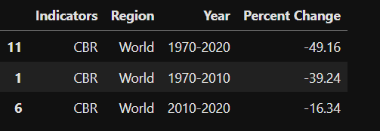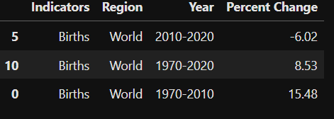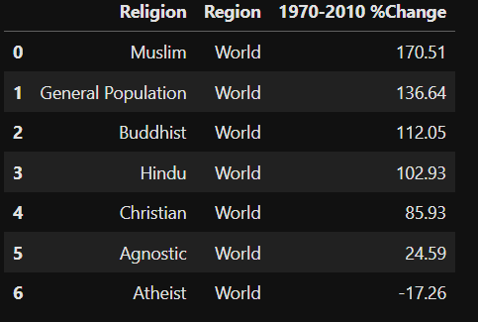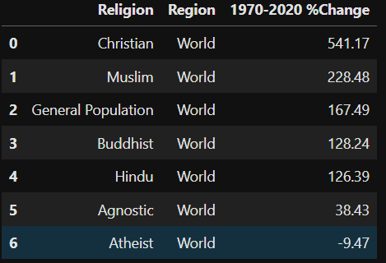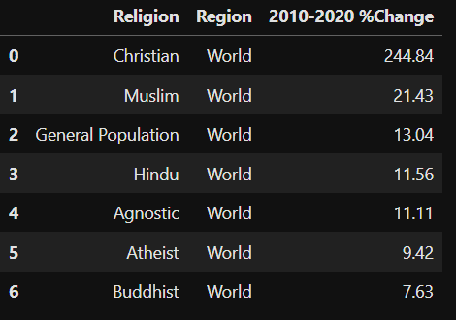

**Continent**

